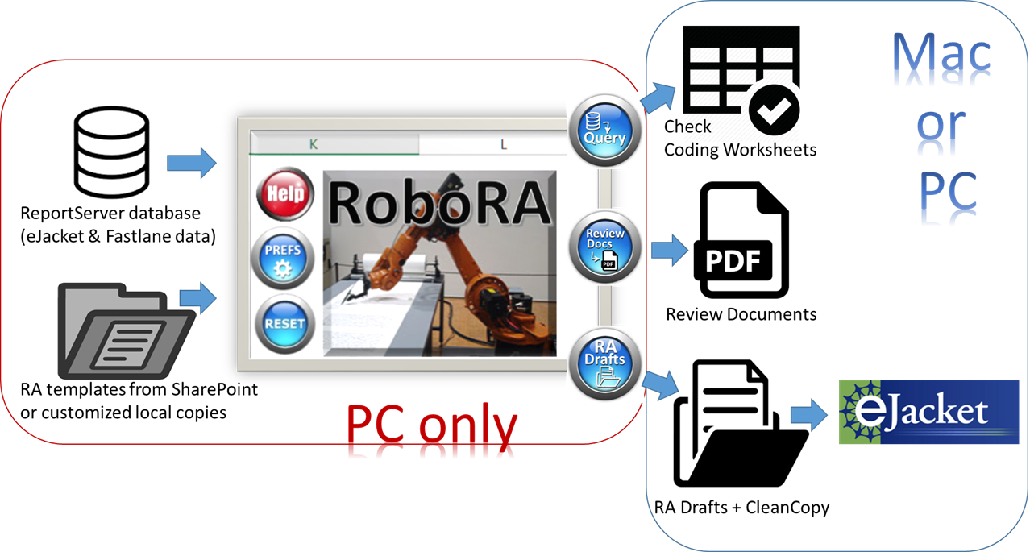RoboRA quick start guide 1/18/2018

**Credits: Jack Snoeyink (author); Grace Yuan (ENG host, testing, & design);  
Wendy Nilsen (template language); Jim Donlon (workflow); & many testers**

[**RoboRA**](https://collaboration.inside.nsf.gov/eng/meritreview/ENG%20Tools%20Websites%20and%20Best%20Practices/RoboRA.aspx)**,**an Excel spreadsheet in the [PD-3PO](https://collaboration.inside.nsf.gov/eng/meritreview/ENG%20Tools%20Websites%20and%20Best%20Practices/PD-3PO.aspx) family of tools, attempts to automate many of the tedious parts of writing **Review Analysis (RA)** documents: It populates [**RA templates**](https://collaboration.inside.nsf.gov/eng/meritreview/ENG%20Tools%20Websites%20and%20Best%20Practices/RoboRA%20templates.aspx) (such as the Awd template on back) with reportserver data to make Word **RA drafts, which** you complete on Mac or PC, then click one button to [CleanCopy](https://collaboration.inside.nsf.gov/eng/meritreview/ENG%20Tools%20Websites%20and%20Best%20Practices/CleanCopy%20macros.aspx) to eJacket. It can also gather [review documents](https://collaboration.inside.nsf.gov/eng/meritreview/ENG%20Tools%20Websites%20and%20Best%20Practices/RoboRA%20gathers%20review%20documents.aspx) into a bookmarked pdf, list amounts from the [latest revised budget](https://collaboration.inside.nsf.gov/eng/meritreview/ENG%20Tools%20Websites%20and%20Best%20Practices/RoboRA%20Budget%20tab.aspx), and [flag miscodes](https://collaboration.inside.nsf.gov/eng/meritreview/ENG%20Tools%20Websites%20and%20Best%20Practices/RoboRA%20facilitates%20checking.aspx).

[Installing RoboRA](https://collaboration.inside.nsf.gov/eng/meritreview/ENG%20Tools%20Websites%20and%20Best%20Practices/RoboRA.aspx" \l "MyAnchor2): From a **PC on the NSF network** or the Virtual Desktop/Citrix **Win 7 or Win 10 Desktop**,  click [RoboRA_v0.8.xlsm](https://collaboration.inside.nsf.gov/eng/meritreview/SiteAssets/ENG%20Tools%20Websites%20and%20Best%20Practices/RoboRA/RoboRA_v0.8.xlsm) and when Excel Online complains, click Open in Excel:  
Enable content, and on the Prefs tab, set the first three. (Defaults are good for the rest.)

1. Test the reportserver connection using your division's userid and password
2. Choose your RA templates by selecting from the table.
3. Save your copy of RoboRA on your R: drive or a local drive.  (Word mail merge cannot use a data source from SharePoint or OneDrive.)

# https://collaboration.inside.nsf.gov/eng/meritreview/SiteAssets/ENG%20Tools%20Websites%20and%20Best%20Practices/PD-3PO/img/RA_basic_selectStdDecl.PNGUsing RoboRA

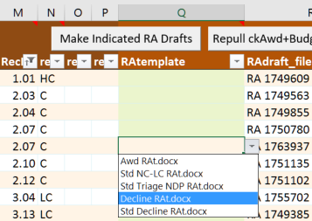In the [basic interface](https://collaboration.inside.nsf.gov/eng/meritreview/ENG%20Tools%20Websites%20and%20Best%20Practices/RoboRA.aspx#MyAnchor3), you list proposal ids to award, decline, or standard decline. Use the menu to restrict proposal status, and buttons to **Query** reportserver and gather **Review Docs**. Check the coding, then make **RA Drafts**.

In the [advanced interface](https://collaboration.inside.nsf.gov/eng/meritreview/ENG%20Tools%20Websites%20and%20Best%20Practices/RoboRA.aspx#MyAnchor4), you specify a set of proposals like in [PD-3PO](https://collaboration.inside.nsf.gov/eng/meritreview/ENG%20Tools%20Websites%20and%20Best%20Practices/PD-3PO.aspx) (say, all pending by program, solicitation, PD, date) and select on the RAData tab which template to use (Awd, Decline, Std Decline, etc.)

The reverse shows a template. In preference 2, if you chose a template folder on your machine, RoboRA will copy the standard templates for you to [customize](https://collaboration.inside.nsf.gov/eng/meritreview/ENG%20Tools%20Websites%20and%20Best%20Practices/RoboRA%20templates.aspx) as desired. Keep in mind that individual customization increases the workload of those doing DD concur.